Content write up for Crosstrack.sg

Main Page

Source for the best matched logistics provider to fulfil your requirements!

*(Choose 3 main points and I will elaborate)*

**Reliable** | Partnering with Reputable Logistics Providers | Trustworthy | **Partnering with Established Logistics Providers** | **Dependable Delivery Partner for You** | Timeliness | Deliver with Promise | Reasonable Pricing | Competitive Pricing | Seamless Delivery through Automation | Automated Delivery Request | Automated Logistics Solutions | Request, Track and Complete your Delivery through Technology | Tracking of Deliveries using Technology | Transparent

*(Mix and match and edit which sentence(s) to put together)*

(At CrossTrack), we believe in providing delivery service that you can depend on - for the long run.

We believe in building long term relationship with you in your delivery needs.

By partnering with established logistics providers, we can match you with a specialised team to fulfil your requirements - At no high rocket pricing or hidden cost.

We will connect you with one of the established logistics providers that specialised in your requirements to work together with you - at no extra cost.

With the use of technology, we will connect/match you with one of the established logistics providers that specialised in your requirements to work together with you - at no extra cost.

(Button 1) Sign Up Now*(link to http://control.crosstrack.sg/new_signup/)  
 (to be changed to Deliver Now page)*

(Button 2) Ask for a Quote *(link to contact us page)*

You will hear from us within 1 hour* of request

(Button 3) Track your Order

*During office hours

*(PHOTOS NOT INCLUDED)*

*add on section/ header : Media*

Contact Us Form*(refer to Charles Schwab* [*Contact Us*](https://www.schwab.com/public/schwab/client_home/contact_us) *page as reference on the layout)*

Our Details

*(To show a map of our location)*

2 Jalan Rajah #05-24   
Golden Wall Flatted Factory   
Singapore 329134   
  
**T :** +65 635 44 635   
**E :** [info@crosstrack.sg](mailto:info@crosstrack.sg)

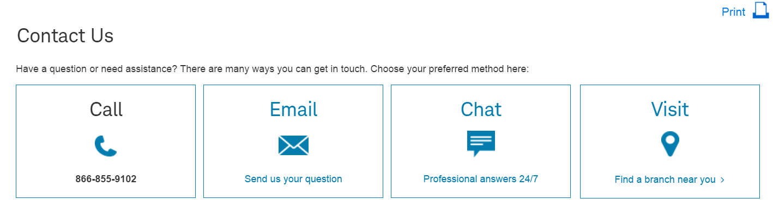

*Change the icon and link the email to info@crosstrack.sg*

Ask for A Quote

Business Enquiry

*Email link to info@crosstrack.sg*

635 44 635

Email enquiry form content:

Name:

Company (optional):

Email Address:

Contact Number (optional):

Your Message *(any max numbers?)*:

Business enquiry content:

Name:

Company:

Email Address:

Contact Number:

Industry:

Brief Description of delivery requirements:

*We will call you within the next 1 hour to understand your needs during office hours

Our Story

A simple wish. A simple story.

During university period whereby I was helping my friend’s printing businesses, delays in deliveries or constant checking on driver’s status becomes part of my daily operations so as to ensure the goods are delivered promptly.

Over time, it becomes so tedious that we wish to simplify the way of doing things in logistics industry.

And that is how we began our journey in CrossTrack.

Be Our Customer

You are setting up your e-commerce shop. Selling fashion wear and other innovative products that aims to bring convenience to customers so that they can make purchasing power anytime, anywhere.

*(OR)* You just set up your e-commerce shop selling fashion wea and other innovative products that aims to make it easy for customers to make purchasing power anytime, anywhere.

In this Age of Customers, feedbacks and words of mouth spread as fast as fire through the virtual world. The least you would want to be troubled with is to hear that your customers being frustrated with the delivery services provided by your partner.

Let us do the worry for you.

=================================================

Frustrated with your documents and parcels not reaching to your customers?

Irritated when your customers call you to ask why is the delivery late?

Finding it hard to get delivery service for your specialised requirements?

Let us do the worry for you- because we understand.

**Simply 3 Reasons to Look for Us**

**Deliver to Your Customer Door Step by Our Reliable/ Trustworthy Partners/ Quality Services/ Reliable Services**

You can expect quality/ reliable deliveries by our partners who looks out in your delivery needs.

**Personalised Customer Support/ Customer Centric Team/ Experienced Customer Support Team**

Spend more time in getting new businesses by entrusting us to arrange delivery schedules with your customers. Our customer service team priorities customers and their needs over anything.

**Experience Seamless Journey with our Technology**

Manage your deliveries easily via our automated platform. You can submit new delivery requests, track your deliveries status and view e-signatures through our online portal.

(Button 1) Sign Up Now *(link to http://control.crosstrack.sg/new_signup/)*

(Button 2) Ask for a Quote if you have special requirements *(link to contact us page)*

You will hear from us within 1 hour* of request

(Button 3) Track your Order

Be Our Partner

Ready to expand your fleet of drivers but yet tied down with daily operations?

Your customers calling you every now and then to check on the delivery status that disrupts your current work?

Are you working day and night managing requests and drivers, handling of manual invoices and the many small issues that calls for your attention?

You have jobs that is unable to fulfil and feel bad to reject the customers?

If you have a 'Yes' to any of the questions, we can work together with you to provide a platform to your operations, finance and customer service needs- through our CrossTrack Management System.

**3 Reasons Why You Need to Automate Your Operations Needs**

**Billing and Tracking of Invoices**

There will be times whereby you are tired of doing reconciliations or to constantly monitor the payment status for the past months’ invoices. Let the system do the job for you. At a glance, you can view the outstanding invoices for each customers’ profile and to resend the invoices to them, if required.

**Real Live Tracking of Delivery Status**

At a click of the mouse, you can have a live status update of the delivery status, whether your driver had completed the jobs assigned or the deliveries were delayed due to traffic conditions. It will be safer than spamming calls, SMSes or whatsapping your drivers when your customer enquire on the status.

**Route Optimization for Your Drivers**

It takes years of experiences and constant updating of the new road names that is sprucing up in Singapore for a Supervisor to plan the driver route the most efficient way. Hopefully.

You can plan the drivers route with our system logic easily and effortlessly.

*(use any of the banners in this page and link the banners to:* <http://www.ida.gov.sg/Collaboration-and-Initiatives/Initiatives/Store/iSPRINT-Packaged-Solutions>*)*

cid:320BB0F24719574FAA3AC9F77A07931A@resoe.gov.sg





(Button 1) Contact Us Now*(link to contact us page)*

(Button 2) Government Grants Available for You

Government Grants Available for You

**1.iSPRINT Packaged Solutions**

CrossTrack is pre-qualified as a Logistics Management System Provider under the Sector (Scale Up) iSPRINT Program. Under this 2-year subscription program, you need to only pay 30% upfront to us and we will work out the remaining amount with IMDA directly.

Eligibility

Your business must meet the following requirements to qualify for iSPRINT.

1. You are a local SME with
   * Company registered or incorporated in Singapore
   * Minimum 30% local shareholding AND
   * Company's Group annual sales turnover not more than S$100 million OR  
     Company's Group employment size not more than 200 workers
2. You do not already own/ use any other solutions that you are going to adopt (i.e. accounting, payroll or POS solution).

Our Package Information:

Total Packaged Price: from S$5,000 to S$50,000

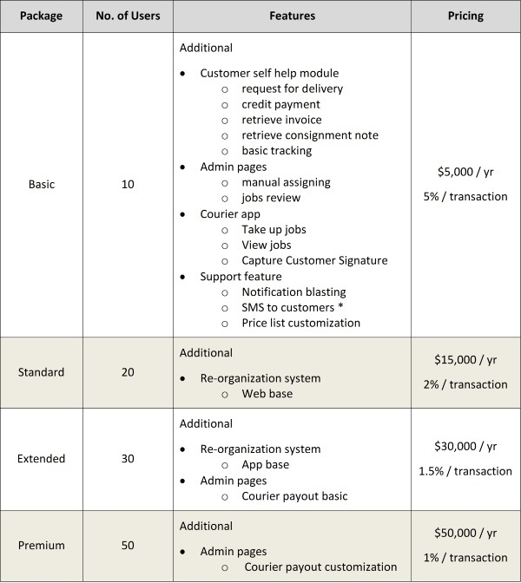   
** SMS charges are not included in the package pricing. SMS is charged at S$0.10 per SMS sent

Included Services  
Any of the packages above includes the following professional services  
a) Consultation Service:  
    i. Logistic Operation Consultation (basic) - 1 session  
b) Training Services:  
    i. Staff Training - 1 session  
    ii. Software Training - 1 session

**Optional Items**  
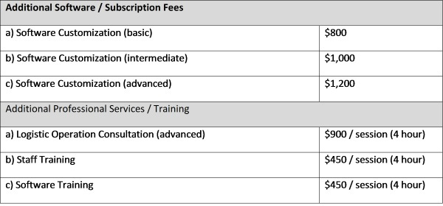

**2.Productivity Innovation Credit (PIC) Grant**

SMEs can stay abreast with their competition and upgrade their operations through the Government Funded Grants and Schemes. The Productivity and Innovation Credit Scheme (PIC) is a simple and easy-to-use grant, which can be used for implementation of digital solutions to improve business productivity and Innovation.

Each SME can apply for a 40% cashback to implement productivity solutions.

Eligibility

To be eligible for the cash payout option, you must have:

* Incurred the necessary qualifying expenditure during the basis periods for YAs 2011 - 2015
* At least 3 local employees (Singapore Citizens or Permanent Residents with Central Provident Fund contributions)
* Active business operations in Singapore

Commonly Asked Questions

1. Do you have a standard pricing structure?
2. How do I post jobs?
3. I can see that credits are needed for me to start requesting for delivery service, how do I purchase the credits?
4. The suggested pricing isn’t within my budget, can it be amended?
5. I need to reschedule my delivery, can it be changed after job had been confirmed?

Privacy Policy

Refer to http://control.crosstrack.sg/privacy_policy/ for the information

Terms of Use

Refer to http://control.crosstrack.sg/terms_of_use/ for the write up